How to construct a MLA Works Cited
Step 1:
- Go to www.easybib.com
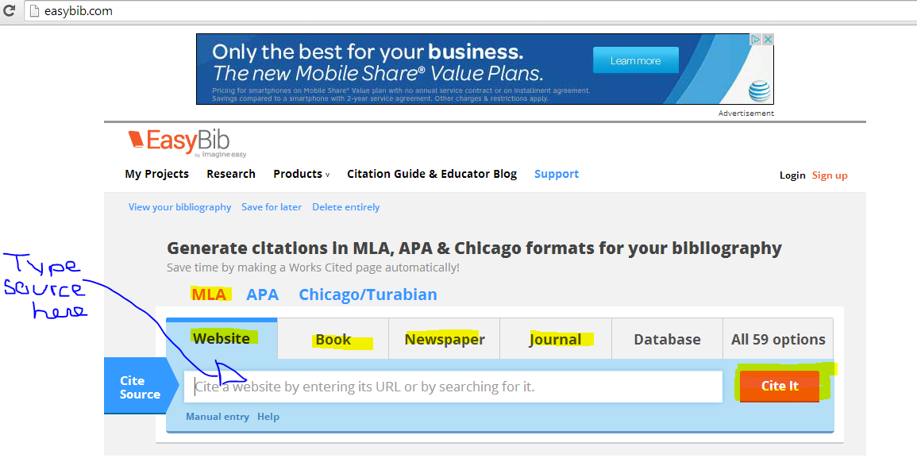
- Choose MLA and the Source you are searching for (Website, book, newspaper, or journal)
- Click “Cite it” when typed in source
Step 2:
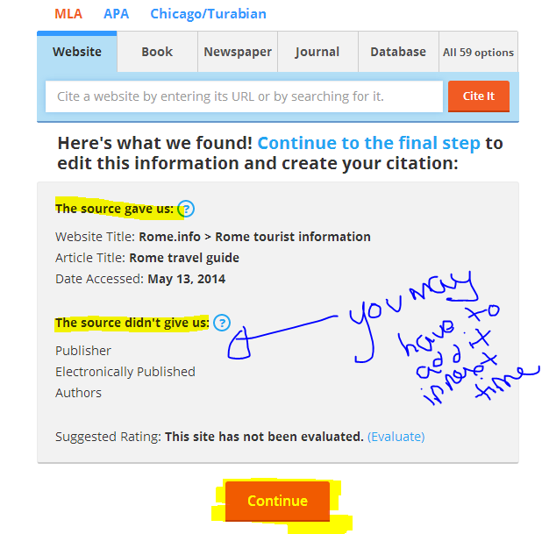
- This next page tells you what easybib found. You may have to input more information from your source. Click continue.

Step 3:
- On the next page, input (edit) information where you can. Whatever is highlighted in RED, you may have to search the website to find (authors, years, contributors, titles, etc).
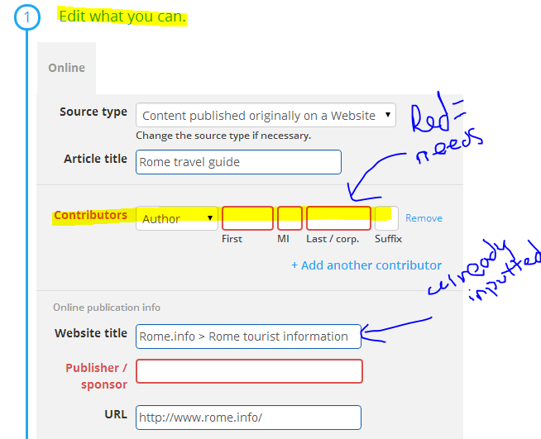
Step 4:
- Click “Create Citation” to create your MLA Citation for your Works Cited!
- Now, go back and input your other sources.
- You will then generate a list.
- Click “Sort order” – to ALPHABETIZE!
- Click “Export/Share” and choose “Copy & Paste”
Step 5:
- Once on the copy&paste page, highlight and copy and paste into your formatted Word Doc.
- You may need to fix the spacing, font, and font size.
- Double check the MLA Formatting on your Works Cited (Word Doc).
